Report CF

**Abstract**

**Efficient Mean-Variance Frontier**

Given three securities with expected returns and corresponding covariances as:

$m= {\left[0.10 0.20 0.15\right]}^{t}$, $C= \left[\begin{matrix} 0.005 & -0.010 & 0.004 \\ -0.010 & 0.040 & -0.002 \\ 0.004 & -0.002 & 0.023\end{matrix}\right]$

Which represent the mean and expected returns of three stocks.

To invest in this, 100 random portfolio were generated ensuring that the weight capital (π) for three assets sum up to one. Since this return is model from random Gaussian distribution, the probability density is localized around one area and spread about the mean. Then the linear transformation property of multivariate Gaussian can be of good help in understanding what to learn and do with the data.

$$x \sim N\left(μ, ε\right);y=Ax; →y \sim N(Aμ, AεA^{t})$$

Expected return and risk are calculated as the mean and variance of the distribution

$$E(r) =π^{t}*m ; V= π*C*π^{t}$$

The efficient (E, V) combinations were computed and the E-V space scatter diagram presented in figure 1.

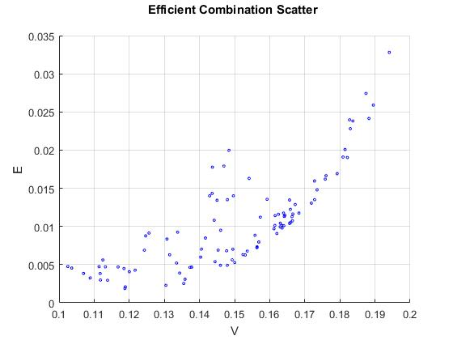

Figure 1 shows each portfolio expected return against allowable risks. Even though it appears that the portfolios with higher returns has higher risks, it can also observed that some portfolio has similar risk but different returns and vice versa. Hence it will be wise to choose carefully a portfolio with maximum return given a particular risk and a portfolio with minimum risk given a particular expected return. Hence portfolio selection should aim at picking few portfolios which give the desired combinations known as efficient combination [1]. This helps in understanding of investment behaviour in terms of mean and variance relationship which represents the desirable returns and undesirable risk in portfolio investment. According to [1] since the future is without uncertainties, a good investor makes provision for risk but maximize the return while minimizing the risk. [1] also encourage diversification in portfolio investment among securities with maximum returns and minimum risks and not on portfolio of large numbers since the combination of securities that has the same value is a good as any of them.

To understand portfolio selection better, I constructed efficient portfolio frontier for the given three-asset model as shown in figure 2.

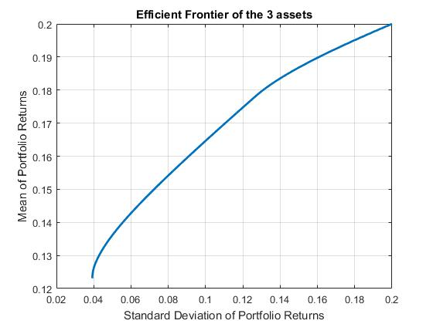

The efficient frontier curve is the benchmark of any set of optimal portfolio with the minimum risks for a defined expected return level and the maximum returns for a defined risk level. This means that no portfolio can be found above the curve and any portfolio below the curve is suboptimal, since the ones on the curve will provide a better return at that risk level.

A step is taken further to evaluate the best combinations of two-asset of the three that best mimic the original three- asset model. This is done by taking the assets pair-wise in turn (their means and Covariances) to estimate their efficient frontier. The efficient frontier graph and scatter points of the various pair-wise combinations are presented in figure 3 and 4 on the same scale for better comparisons.

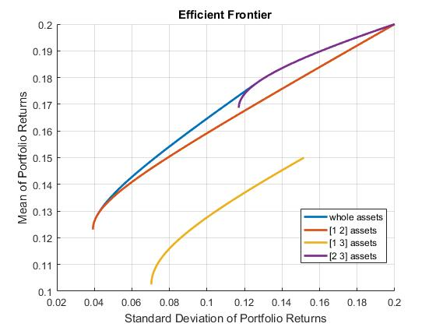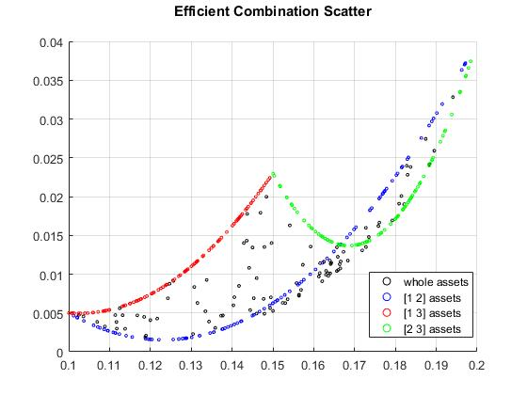

From figure 3 above, it can be seen that some combinations of the assets tries to approximate to the original market index. Assets [1 2] and [2 3] combinations try to mimic the original three-asset combinations. Assets [2 3] best mimic the whole assets market behaviour but at high risk. Assets [1 2] can be selected for an investor who is interested in little or no risk. I is not able to approximate the return at the middle. Assets [1 3] is highly suboptimal and that combination should be discouraged. The scatter diagram in figure 4 also should the Expected return – Variance relationship of the pairwise combination of the assets and it could also be seen that asset [1 2] try to mimic the whole asset portfolio. Asset [2 3] can be chosen if the investor is willing to tolerate high risk rate. For me, instead of buying all the assets, I will buy only assets [1 2] combinations and use the balance for some other thing.

Why Linear Programming is used in NaiveMV function for computing the efficient frontier

Linear programming (linprog) in MATLAB can only be used if the problem is entirely linear. Linprog is used in the NaiveMV method because the task is purely a scalar product which is linear and all the constraints that it’s subjected to are all linear without any quadratic term. In the NaiveMV function, the task of estimating the efficient frontier is divided into three. The first part estimate the expected return without any reference to the variance, hence, estimate the maximum returns as high as possible. This part is a linear programming problem. The second part estimates lowest variance without any reference to the expected return, hence, can get the lowest possible variance. This part is a quadratic programming problem. The last part try to estimate expected return from a number of points within the interval calculated from the first two parts given any level of risk.

The use of linprog is to find that maximum expected return when risk is not put into considerations [2]. In the NaiveMV function, we want to find out the maximum return portfolio unconstrained by any risk and the maximum return constrained by the minimum risk portfolio.

CVX Convex Programming toolbox

In this segment, the linprog and quodprog used in NaiveMV function were replaced by CVX and similar results were produced. This is because CVX toolbox solves constraint optimization problem very efficiently as well. Its advantage is that it allows the expression of convex optimization problem in a natural mathematical syntax [2].

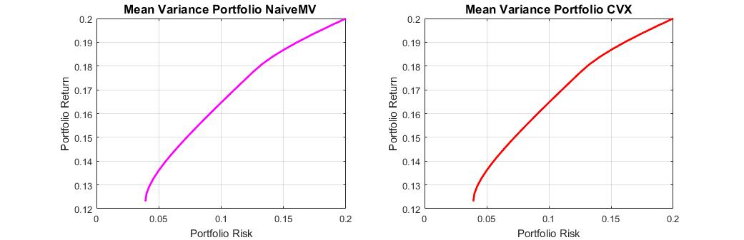

**Evaluation of Performance of Optimal and Naïve Diversification**

It will be interesting to re-experiment the portfolio selection on real data. In this section, real data were obtained from Google Finance data. This comprises of daily FTSE 100 data and data for the prices of 30 companies in the FTSE index for the past three years (running from 2014-03-02 to 2017-03-02).

For portfolio selection, 3 out of 30 stocks were selected at random and built into a time series matrix of three stocks, then, split equally into training and test sets. The training half is the earlier dates while the testing half is the later dates. Missing values in the time series were filled with next preceding values, hence their return for those days will be zeros.

The daily return were computed for the three stocks using the formula (1) to build the return matrix. In doing this, I built a financial time series with the financial data and calculate the daily returns using:

$r\left(t\right)=\frac{S\left(t\right) - S(t-1)}{S(t-1)}= \frac{S\left(t\right)}{S(t-1)}-1$………… (1)

Where r (t) = return at time t and S (t) = stock price at time t.

The expected Returns and Covariances were estimated from the training set of the time series. expected returns and covariances for the three stock are:

$m= {\left[-0.0962 0.5039 0.1639\right]}^{t}$, $C= \left[\begin{matrix}24.2032 & -0.9656 & -0.3310 \\ -0.9656 & 329.5706 & 68.6455 \\ -0.3310 & 68.6455 & 41.2816\end{matrix}\right]$

The Markowitz portfolio weight for the three stocks were computed using convex optimization approach.

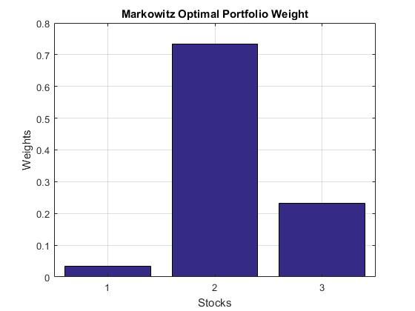

Using the estimates, efficient portfolio was design. It was observed that any portfolios pick at random from the efficient portfolio fall on the curve of the efficient frontier. This shows that the efficient frontier defines the maximum performance of a portfolio in market index when the efficient combination is made.

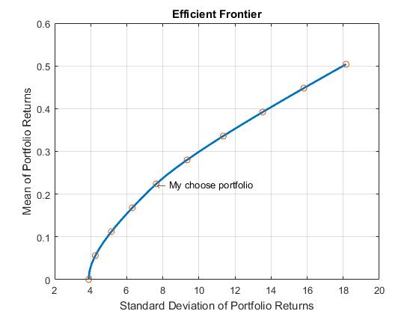

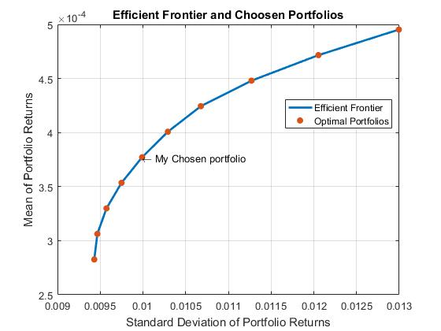

Design of Naïve Equal Weight Portfolio

Simple naïve equal weight diversification rule assigns equal $\frac{1}{N}$ weights to N available assets for investment [5]. According to [5], the optimal diversification rule may outperform $\frac{1}{N}$ naïve rule in a very large dataset but not consistently. The task now is to verify this claim.

Give three stocks for investment at each rebalancing, the naive weight w = $[0.3333 0.3333 0.3333]$.

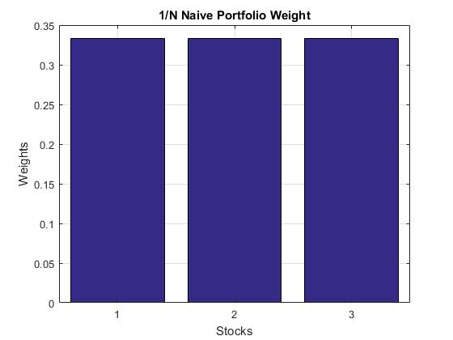

This is less complicated, simple, straightforward, very easy to implement. It does not require any optimization nor estimation of the moments of asset returns [5].

Experimenting on the test data

The performance of the Markowitz portfolio and that of $\frac{1}{N}$ Naïve portfolio were computed and compared on both the training and testing data.

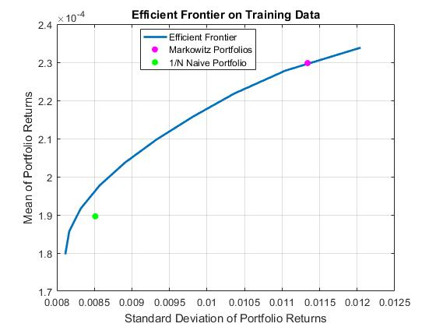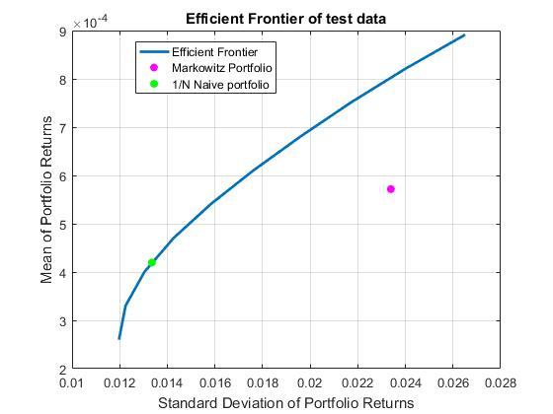

It is observed that the Markowitz weight learnt the training data but fail to fit well in the out-of-sample data.

To properly compare the performance of the Markowitz portfolio and simple naïve $\frac{1}{N}$ equal weight portfolio on the test data, Sharpe ratio approach was used.

Comparison of Portfolio Performance using Sharpe Ratio

Sharpe ratio is the mean to standard deviation of portfolio return. This approach analysis a portfolio in terms of its return-to-risk value. A portfolio is said to outperform another portfolio if it maximizes its sharpe ratio more than the other portfolio when compared on the same risk scale [5]. This means that maximum sharpe ratio portfolios are located on the efficient frontier.

The Sharpe ratio of a portfolio is computed using formula:

$S=\frac{m-r}{σ}$ where r = risk free interest rate, m = expected return, $σ$ = expected standard deviation

The risk free interest rate is not considered in this experiment, hence, it is set to zero and the sharpe ratio formula becomes: $S=\frac{m}{σ}$

The Markowitz optimal weight and Naïve equal weight rule portfolio were performed on different 3 random stocks and their portfolios evaluated based on sharpe ratio. The results are presented in figure 7.

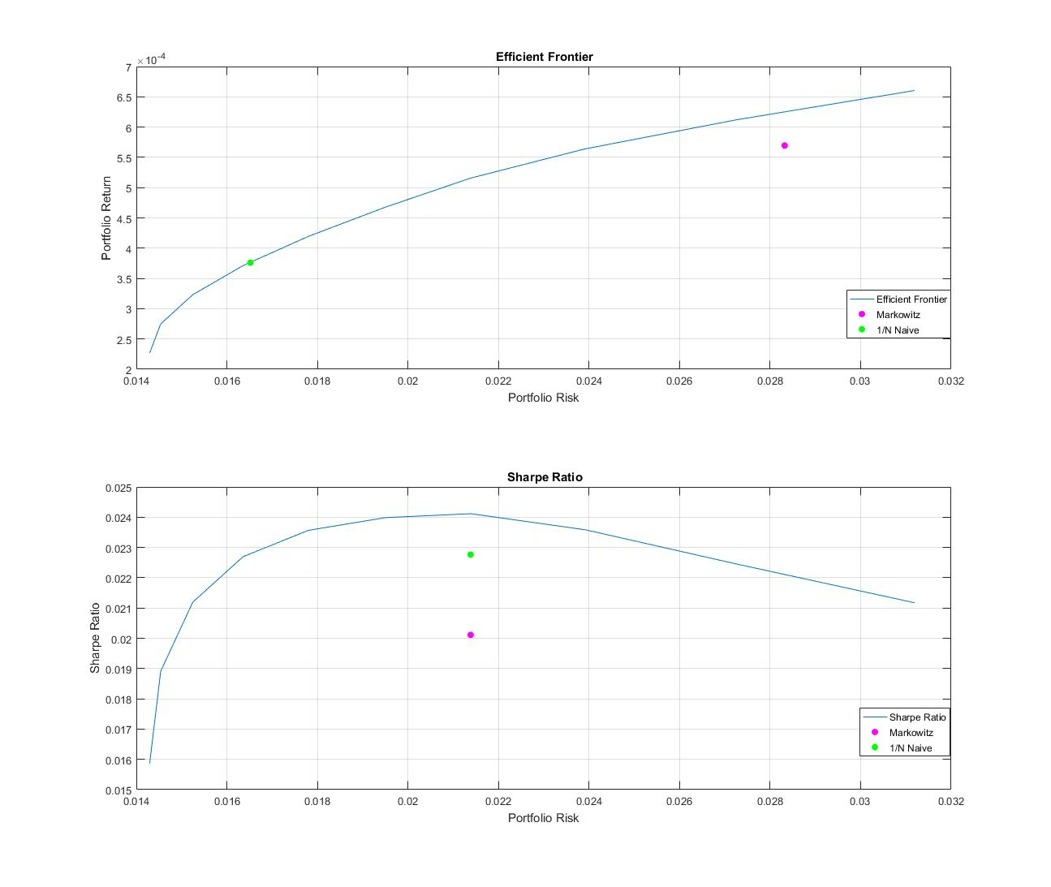

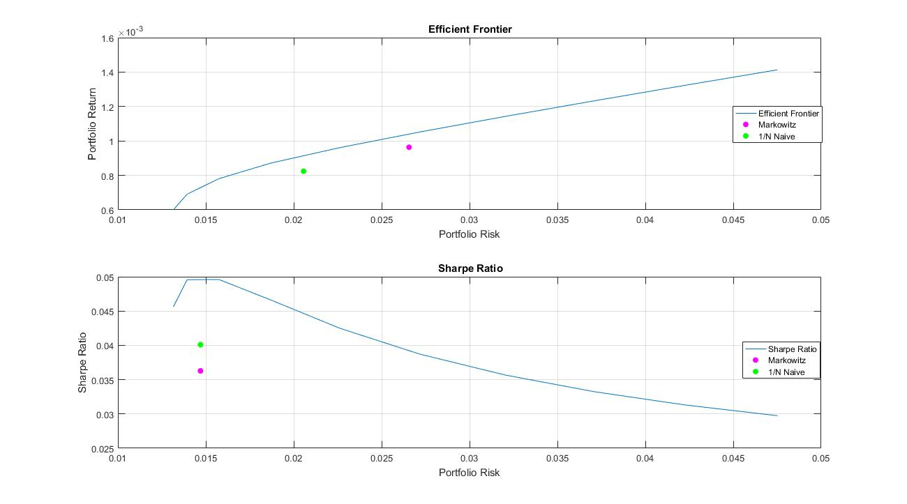

It is observed that the optimal diversification method does not perform better than the Naïve equal weight rule. *The result shows that 1/N naïve-diversification rule improves the potential for diversification while increasing the number of parameters to be estimated by an optimizing model.* Owing to the size of my dataset which spam for 3 years, 1/N still prove to be better. Hence, I support the suggestion made by [3] that 1/N naïve rule should be used as a benchmark for assessing the performance of more sophisticated asset allocation rules.

**Index Tracking**

The FTSE 100 market index shows the performance of the combination of the whole 100 stocks. For one to be able to get the same return, the most passive way of doing so is to invest in all the 100 stocks. Only billionaires can do that but that is not brilliant enough. The question is how to invest in a small subset of the whole stocks and still get similar returns as investing in the whole 100 stocks.

The objective of this exercise is implement various method of optimal portfolio selection and see which is able to track correctly the original market index based on few assets selection. In this exercise, greedy selection algorithm and sparse index tracking algorithm were implemented. The return matrix of the 30 stocks obtained in section 2 was built and the algorithms were constrained to select only a fifth of the whole available stocks that can best track the original index. This is evaluated on out-of-sample data.

*In section one, we saw that combination of assets [1 2] approximate the performance of the whole assets whereas assets [1 3] combination is as good as not contributing any positive return. Hence, the task now is to find those best assets combination that will give the best return as good as the whole market index and avoid those whose contributions are insignificant. To achieve this, we have to track the index of the market.*

**Greedy Forward Selection Algorithm**

Greedy forward selection algorithm uses a heuristics that enables it to select the first assets combinations that gives an optimal return. Its approach entails picking the first asset with maximum return and using it as a permanent member in the efficient combination portfolio and goes further to select the best two assets combination. These two assets becomes permanent member of the set to select three best combination until a desired number of assets combination is achieved [6]. It is greedy because, it does not go back to check if an asset that does not make the list in the first few combination can actually combine with other assets and outperform the approximation function of already greedily selected assets. It does not have different N combinations to compare against each other, rather every selective combination is built around earlier selected combination.

The algorithm provided by [6] was used to implement greedy selection of 6 best assets combination.

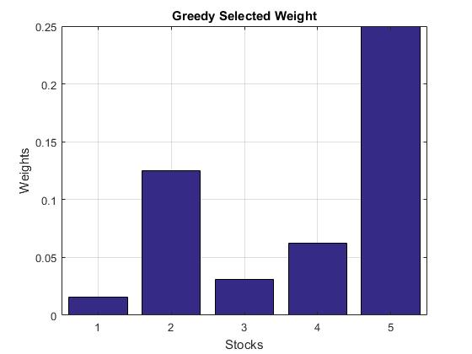

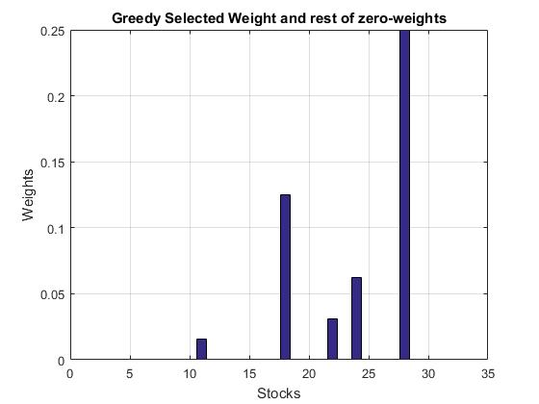

**Sparse Index Tracking Algorithm**

Sparse Index Tracking enable us to track the few asset combination that best approximate the performance of the FTSE market index by checking all possible combinatorial solution. In this approach, I used the CVX convex optimization to select the six assets that best mimic the market index. I added a regularization term as discussed in [1] following the equation:

$$w^{T}=\arg{\min{ [{ \left|\left|y-Rw\right|\right|}_{2}^{2}+T{\left|\left|w\right|\right|}_{1} ]}}$$

The penalty term T is tune from 0.03 to 0.3 and the graph in figure shows the number of non-zeros weights as a function of the regularization term. The aim of the tuning is to have only a fifth of the assets that are non-zero weights which will be the most optimal combination forming stable and robust portfolio.

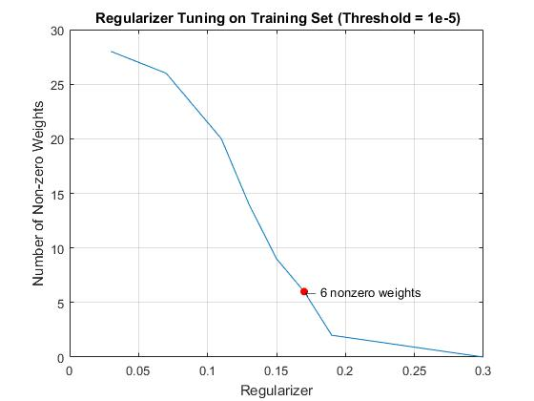

The threshold is necessary especially in a situation where short selling of assets is allowed since some assets will have negative weights.

It was not easy to get a stable portfolio. Bootstrapping technique was implemented on the underlying data under 20 simulations and the most optimal was picked based on Sharpe ratio.

The sparse index tracking weight produces 1/5 assets combination using a regularization term of 0.3 at the threshold of 1e-5 as shown in figure 5 below.

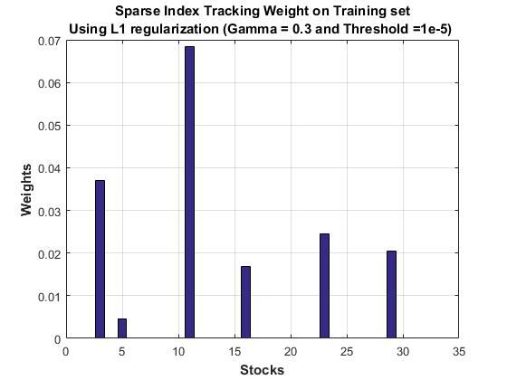

Comparison of the Greedy selection Tracking and Sparse Index Tracking

To compare the two algorithm discussed above, the Sharpe ratio of their resulting portfolio were computed and presented below.

Also their tracking error were also computed and the asset with the least tracking error is the sparse index tracking which makes it a better index tracking algorithm.

|  |  |
| --- | --- |
| Index Tracking Methods | Tracking Error |
| Greedy Selection Algorithm | 9.364580877015413 |
| Sparse Index Tracking | 4.296096181136993 |

The sparse index tracking algorithm is able to outperform the greedy selection because it does not greedily continue its selection with the first few assets that produces the best efficient combination instead it has a way of re-evaluating it against other combinations chosen at each permutation. This is combinatorial complexity problem but it produces a better result than greedy selection approach.

**Inclusion of Transaction Costs in Optimizing Adjustments to a Portfolio**

Conclusion

References

1. H. Markowitz, “Portfolio selection," *The Journal of Finance*, vol. 7, no. 1, pp. 77-91, 1952.
2. P. Brandimarte, *Numerical Methods in Finance and Economics*. Wiley, 2006.
3. V. DeMiguel, L. Garlappi, and R. Uppal, “Optimal versus naive diversification: How inefficient is the 1/n portfolio strategy?" *The Review of Financial Studies*, vol. 22, no. 5, pp.1915 - 1953, 2009.
4. J. Brodie, I. Daubechies, C. De Mol, D. Giannone, and I. Loris, “Sparse and stable Markowitz portfolios," *PNAS*, vol. 106, no. 30, pp. 12267-12272, 2009.
5. M. Lobo, M. Fazel, and S. Boyd, “Portfolio optimization with linear and fixed transaction costs," *Annals of Operations Research*, vol. 152, no. 1, pp. 341-365, 2007.

[x] S. Diamond and S. Boyd, “CVXPY: A Python-Embedded Modelling Language for Convex Optimization,” *Journal of Machine Learning Research.* vol. 17. pp. 1-5, 2016.

1. R. C. Grinold and R. N. Kahn (2000), Active Portfolio Management, 2nd ed.
2. H. M. Markowitz (1952), "Portfolio Selection," Journal of Finance, Vol. 1, No. 1, pp. 77-91.
3. J. Lintner (1965), "The Valuation of Risk Assets and the Selection of Risky Investments in Stock Portfolios and Capital Budgets," Review of Economics and Statistics, Vol. 47, No. 1, pp. 13-37.
4. H. M. Markowitz (1959), Portfolio Selection: Efficient Diversification of Investments, John Wiley & Sons, Inc.
5. W. F. Sharpe (1966), "Mutual Fund Performance," Journal of Business, Vol. 39, No. 1, Part 2, pp. 119-138.
6. J. Tobin (1958), "Liquidity Preference as Behavior Towards Risk," Review of Economic Studies, Vol. 25, No.1, pp. 65-86.
7. J. L. Treynor and F. Black (1973), "How to Use Security Analysis to Improve Portfolio Selection," Journal of Business, Vol. 46, No. 1, pp. 68-86.

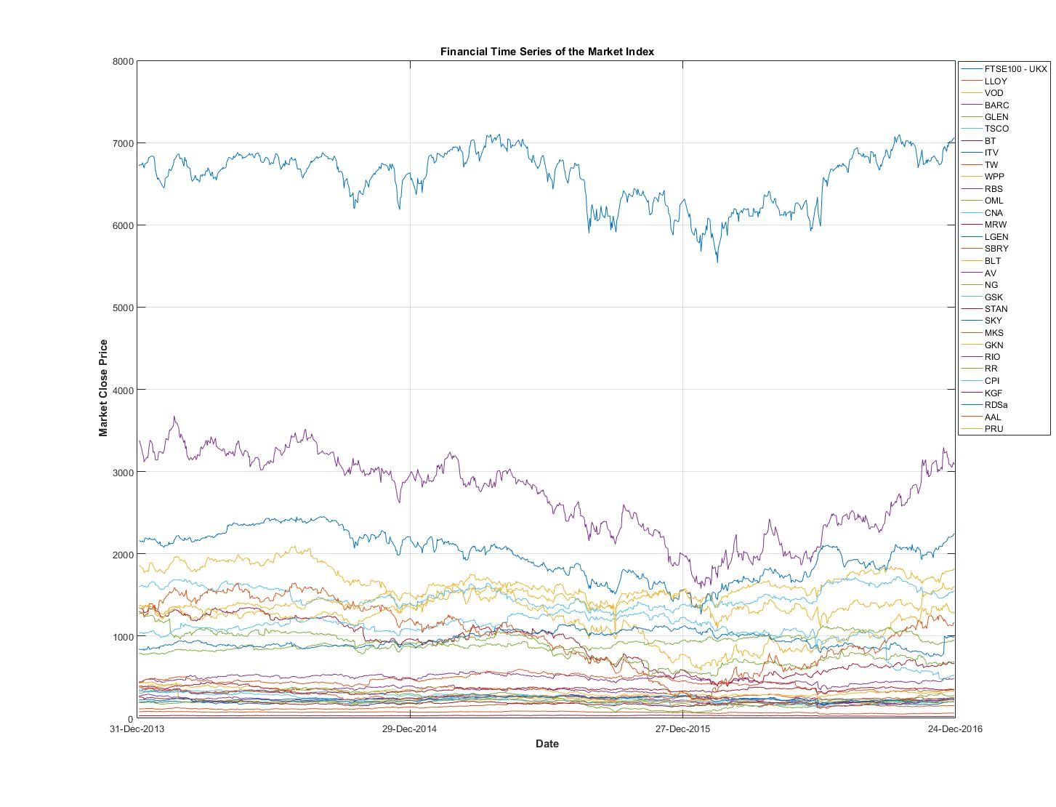

No. 2

I modelled the data in time series and used the Financial toolbox to fill in the missing values by nearest value which is the same as filling the missing return with zero.

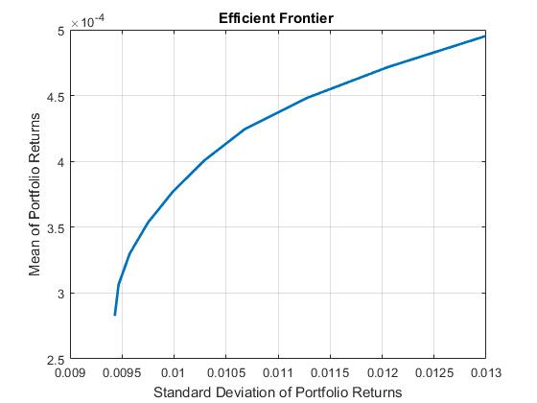

Every optimal portfolio selected fall on the efficient portfolio curve.



1/N Portfolio weight [1/3 1/3 1/3]

TRY

1. Bootstrapping
2. Using different weights
3. As in lab 4 ML
4. Plot of non-zero weights as a function of regularizer
5. Threshold

Training Tracking errors:

'My Greedy = ' [4.2923]

'Niranjan Greedy = ' [6.3953]

'Sparse = ' [4.2911]

Tesing Tracking errors:

'My Greedy = ' [4.2953]

'Niranjan Greedy = ' [9.3646]

'Sparse = ' [4.2961]



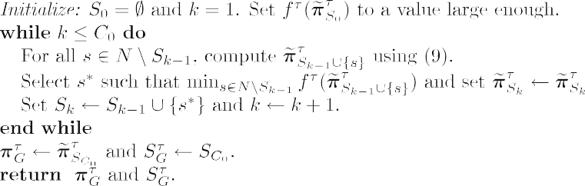

Algorithm 1: Greedy Algorithm

Initialize: So = { }, k = 1, set fT(

My Ref

1. J. Brodie, I. Daubechies, C. De Mol, D. Giannone, and I. Loris, “Sparse and stable Markowitz portfolios," *PNAS*, vol. 106, no. 30, pp. 12267-12272, 2009.
2. H. Markowitz, “Portfolio selection," *The Journal of Finance*, vol. 7, no. 1, pp. 77-91, 1952.
3. P. Brandimarte, *Numerical Methods in Finance and Economics*. Wiley, 2006.
4. S. Diamond and S. Boyd, “CVXPY: A Python-Embedded Modelling Language for Convex Optimization,” *Journal of Machine Learning Research.* vol. 17. pp. 1-5, 2016.
5. V. DeMiguel, L. Garlappi, and R. Uppal, “Optimal versus naive diversification: How inefficient is the 1/n portfolio strategy?" *The Review of Financial Studies*, vol. 22, no. 5, pp.1915 - 1953, 2009.
6. Akiko Takeda, Mahesan Niranjan, Jun-ya Gotoh and Yoshinobu Kawahara, “Simultaneous pursuit of out-of-sample performance and sparsity in index tracking portfolios,” Springer ,Comput Manag Sci vol. 10, pp.21–49, 2013.